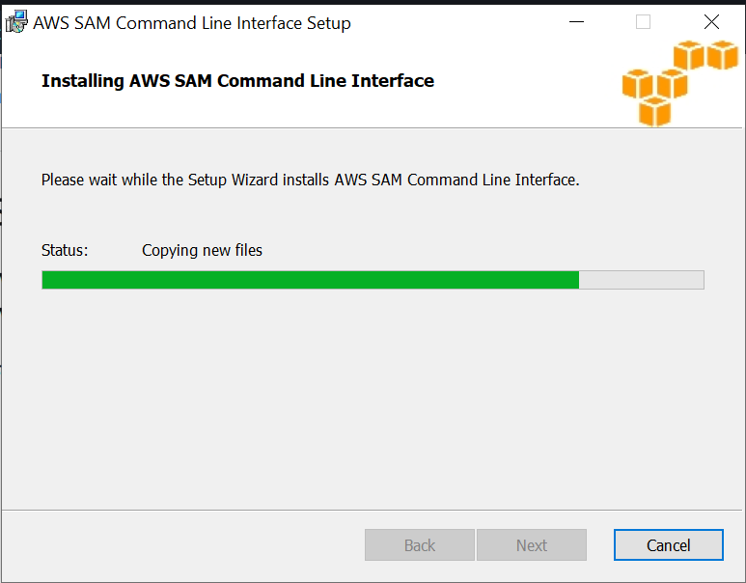

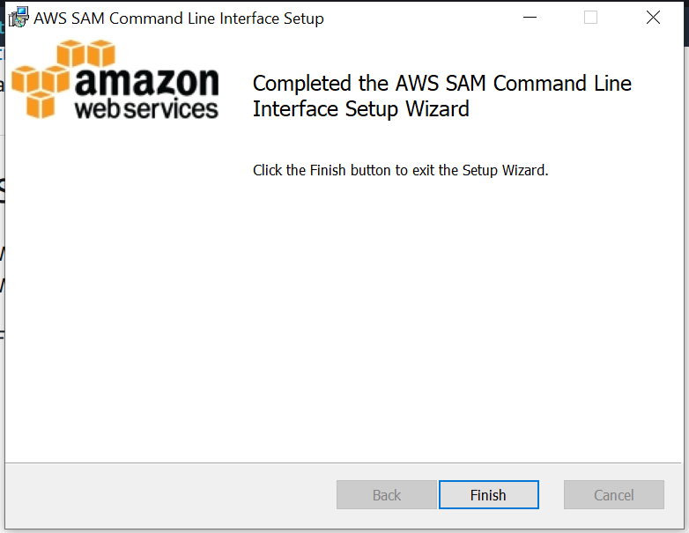

Verify the installation.

After completing the installation, verify it by opening a new command prompt or PowerShell prompt. You should be able to invoke sam from the command line.

sam –version

sam build